 CHEMICAL ENGINEERING TRANSACTIONS  VOL. xxx, 2026 | A publication of  
The Italian Association
of Chemical Engineering
Online at www.cetjournal.it

Guest Editors: Valerio Cozzani, Bruno Fabiano, Genserik Reniers
Copyright © 2026, AIDIC Servizi S.r.l.
ISBN 979-12-81206-xx-x; ISSN 2283-9216

Development of a system to test the ability of operators to intervene in the event of a cyber attack in the process industry
Gabriele Baldissoneª*, Salvina Murèª, Chidera Amazuª, Davide Fissoreª, Micaela Demichelaª
ªPolitecnico di Torino, DISAT, Corso Duca degli Abruzzi 24, Torino, Italy
* gabriele.baldissone@polito.it]
Today, process plants are highly automated. Control room operators can modify the operating parameters of various equipment. A computerized system is used to do this. This approach limits the number of personnel employed and improves system efficiency. However, it also opens up new vulnerabilities, such as cyber attacks. Cyber attacks in this case can also have physical consequences, causing incidents.
In the event of cyber attacks, various IT barriers are present, but these can be overcome and affect operating systems. One of the last barriers that can still intervene is the operator, who can detect the attack and take the necessary countermeasures.
To safely test this operator skill, a simulator of a process plant's interface system was developed. In this simulator, volunteers are presented with examples of cyber attacks to assess their ability to identify the attack and respond appropriately.
This paper introduces the system developed for testing operator skills and the examples used for testing.

  - Introduction

Currently, numerous industrial plants are interconnected to the information network with the objective of processing process data in real time, thus enabling a significant improvement in operational efficiency and control of the entire production system (Xiangyu et al., 2013). However, this digital interconnection simultaneously opens new opportunities for cyber intrusion within the plants, generating unprecedented and complex threats that did not exist when industrial systems operated in isolation (Ani et al., 2016).
Past experience has dramatically demonstrated how cyber-attacks can translate into concrete and dangerous consequences in the physical world. In some documented cases, such attacks have caused injuries to people (Leyden, 2008), while in others they have caused serious production problems with considerable economic repercussions (Langner, 2011). These incidents constitute tangible proof of the fact that, in certain particularly sensitive industrial sectors, cyber aggressions can transcend the virtual dimension to manifest themselves in real and measurable damage in the physical world.
Precisely in light of this critical evidence, over the years a substantial body of research and implementation has developed aimed at strengthening the cyber security of industrial plants. This effort has materialized through diversified interventions in multiple specialized areas, including: the development of robust and layered security architectures (Jones and Horowitz 2012), the definition and implementation of security policies (Bertolotti et al., 2013), the systematic execution of scans for vulnerability identification (Coffey et al., 2018, Seara and Serrão, 2024), the implementation of advanced authentication systems (Chakravarthy et al., 2010, Genge et al., 2018), sophisticated access control mechanisms (Yalcinkaya et al., 2017, Mayeke et al, 2024), data encryption technologies (Xu et al., 2017, Wadho et al., 2023), and intrusion detection systems (Dolgikh et al., 2011, Markevych and Dawson, 2023).
Although all these tools and methodologies contribute significantly to consolidating the cyber component of industrial plants, creating multiple defensive barriers (Zhang et al., 2024), it is necessary to recognize that no system is completely inviolable. Once a determined attacker equipped with adequate resources manages to overcome these digital defenses, there are still margins for intervention to prevent or mitigate damage in the physical world.
It is precisely in this perspective that the concept of defense in depth emerges: between the initial cyber-attack and its potential damaging physical consequences, several layers of protection can and must be interposed. These defense levels are not homogeneous but heterogeneous in nature and functioning, comprising some measures of a purely IT nature, others strictly related to the industrial processes themselves, systems that rely on human intervention and judgment, as well as passive protection systems that operate automatically without the need for external input. This multi-level and multidisciplinary stratification of protections constitutes the most effective strategy to ensure that, even in the event of a cyber security compromise, the consequences in the real world can be contained or completely avoided.
One of the most important and critical layers of protection within the defense in depth strategy is represented by the human factor, constituted by the control room operator. This human element often represents the last line of defense between a cyber-attack and its potential physical consequences. The control room operator, however, must be adequately prepared and trained to intervene effectively in a multitude of diversified scenarios that can involve the process plant. These scenarios range from traditional and well-known ones, such as mechanical failures, system malfunctions or human errors, to new and complex eventualities that characterize the contemporary landscape, such as NATECH scenarios - natural events that trigger technological consequences (Castro et al., 2023) - and, increasingly frequently, cyber-attacks.
Cyber-attacks represent one of the most significant and insidious challenges that can involve control room operators. The peculiarity of these threats lies in their subtle and multiform nature: they can manifest themselves through the presentation of falsified or manipulated data that induce the operator to make decisions based on false information, the complete loss of remote control functionalities leaving the operator without essential operational tools, or hidden modifications of settings and process parameters that silently alter the behavior of the plant without evident alarm signals. To effectively address these threats, the skills, technical competencies and specific training of control room operators are fundamental and essential.
In this context, the need to systematically test and evaluate the abilities of control room operators to promptly identify ongoing cyber-attacks and to act appropriately and effectively to mitigate their consequences assumes particular relevance.
This paper illustrates the development of an innovative testing system specifically designed to evaluate the competencies of control room operators in cyber-attack scenarios. Furthermore, the development and characterization of various realistic cyber-attack scenarios to be proposed to operators during test sessions is presented, thus allowing the evaluation of their capabilities in anomaly recognition, situation diagnosis and operational response under controlled but realistic conditions.

  - Test system

This chapter briefly describes the control room simulator used in this study and the next paragraph describes the case studies developed to estimate the operator's readiness in the event of a cyber attack.

    - Control room simulator
To test operators in case of cyber attacks, a control room workstation simulator has been developed, similar to the one previously presented (Amazu et al., 2024). The simulator replicates a continuous formaldehyde production plant based on partial oxidation of methanol, providing a realistic training environment for operators to experience and respond to potential cybersecurity threats.
The simulation system is built on a Digital Twin of the plant, which uses a first-principles dynamic model. This sophisticated model is capable of accurately representing the plant's dynamic behavior as process parameters vary according to operator inputs through the various interfaces. Furthermore, the model can also reproduce and demonstrate to the operator how the plant would behave when a cyber attack successfully modifies the settings of certain process variables, allowing operators to recognize anomalous conditions and practice appropriate response procedures.
The operator interacts with the model through a series of interfaces displayed across three monitors (Figure 1), mimicking an actual industrial control room setup.

Figure 1:Schema of the simulator used for the test.
The central monitor (Figure 2) displays the comprehensive plant schematic with real-time values of the main process variables, providing an at-a-glance overview of the entire operation. At the bottom of the screen, the operator can access different control interfaces for various plant sections, including methanol storage, methanol pumping and vaporization, air and recycle gas compression, heat recovery, reaction, and formaldehyde absorption in water. Each section can be controlled and monitored independently while maintaining awareness of the overall plant status.
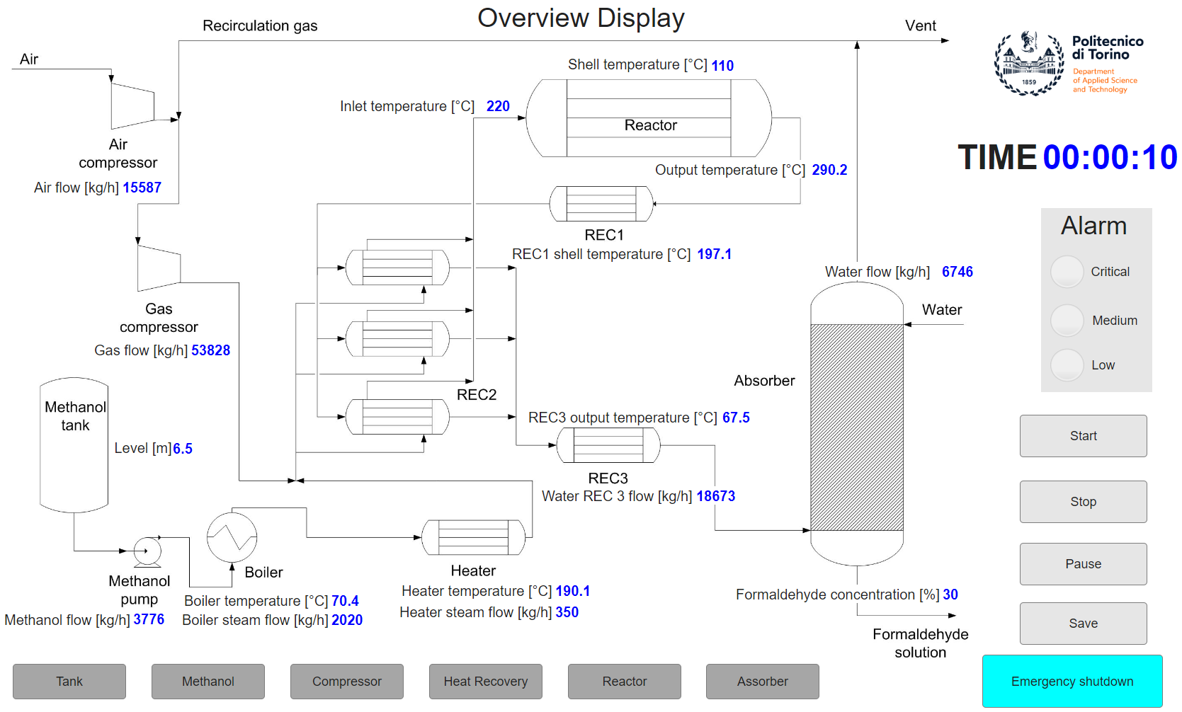
Figure 2:Central interface

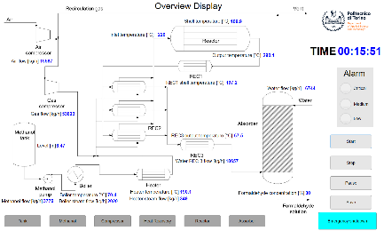
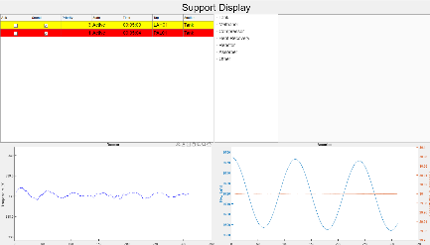
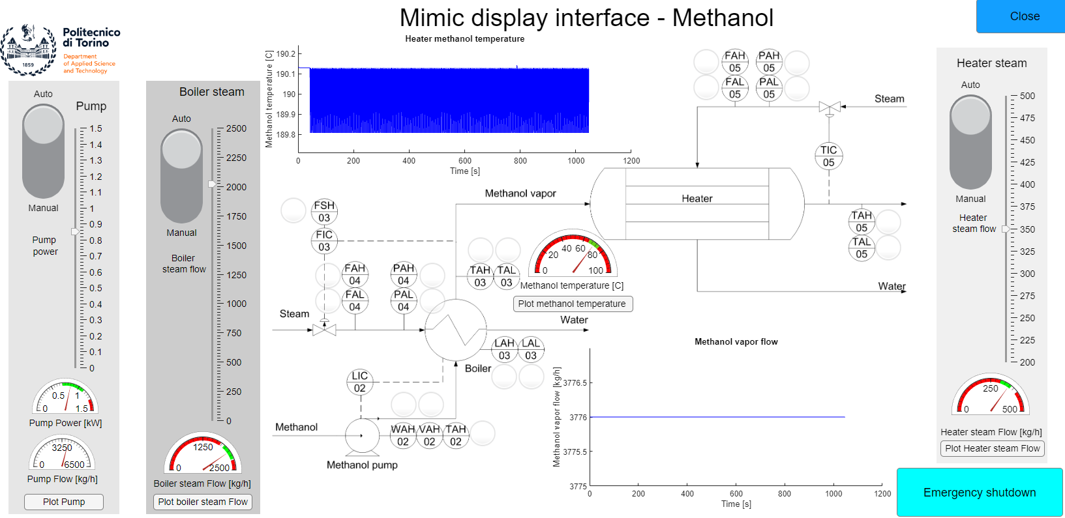

The right monitor (Figure 3) contains an information and operator support interface, which serves as a critical decision-support tool. This interface includes the active alarms list, which displays current plant abnormalities and alerts requiring operator attention, as well as an available procedures list that guides operators through standard and emergency response protocols. Additionally, it features graphical displays of key process variable trends over time, allowing operators to identify patterns and predict future plant behavior. The monitor also includes a chat-based connection system with support services such as IT, maintenance, and engineering teams, enabling rapid communication and collaboration during critical situations.
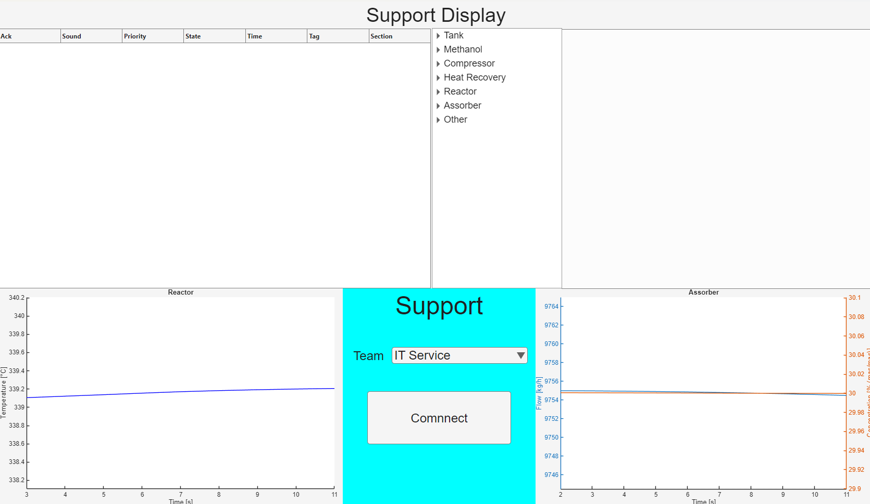
The left monitor displays the control interfaces for various plant sections, providing detailed control capabilities for specific operations. Figure 4 shows the formaldehyde absorption system control interface as an example of these detailed control screens. Through these interfaces, the operator can view current values and historical trends of process variables with high precision and granularity. Additionally, the operator can switch to manual management of process variables, bypassing the automatic control system when necessary, which is particularly important during cyber attack scenarios where automated systems may be compromised or behaving unpredictably.
Figure 3:Information and support interface

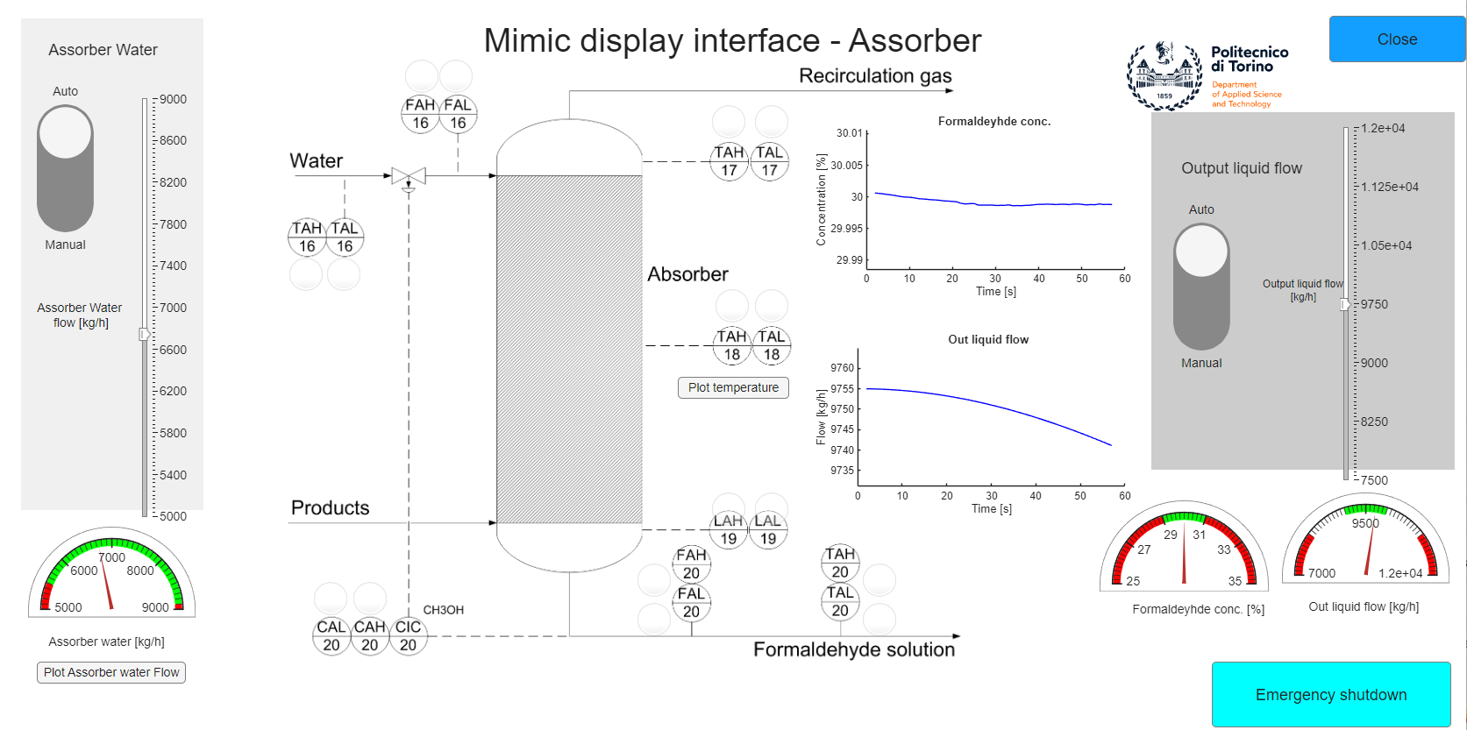
Figure 4:Assorpition interface
    - Case study
For the operator test, two scenarios were developed to simulate a man-in-the-middle cyber attack. In both scenarios, a malicious actor alters a process variable, and the operator is required to detect the manipulation and take corrective action.
In the first case study, a cyber attack reduces the nitrogen inertization flow rate (Figure 5) of the methanol storage tank, leading to a decrease in tank pressure. Once the operator notices the modification, they are required to restore the correct flow rate. After a certain period of time, a second attack is simulated, increasing the nitrogen flow rate and consequently causing an increase in the tank pressure. In this situation as well, the operator must recognize the anomaly and manually restore the nominal operating conditions.
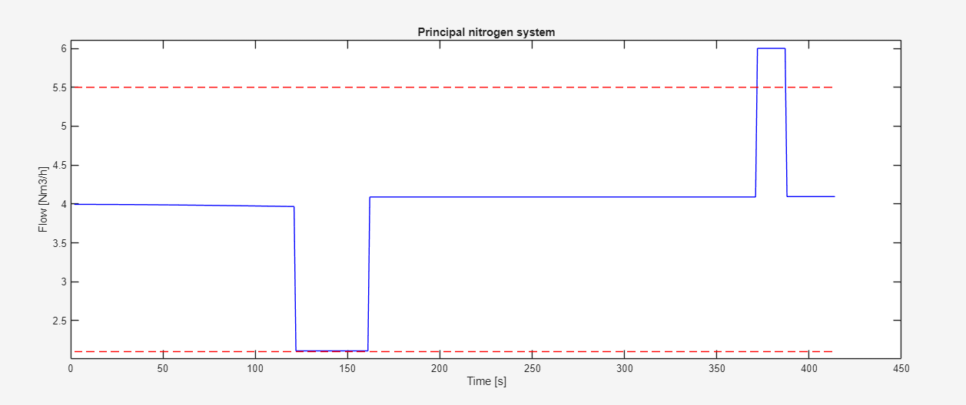
Cyber attack
Operator
Figure 5: Nitrogen flow in the first case studio
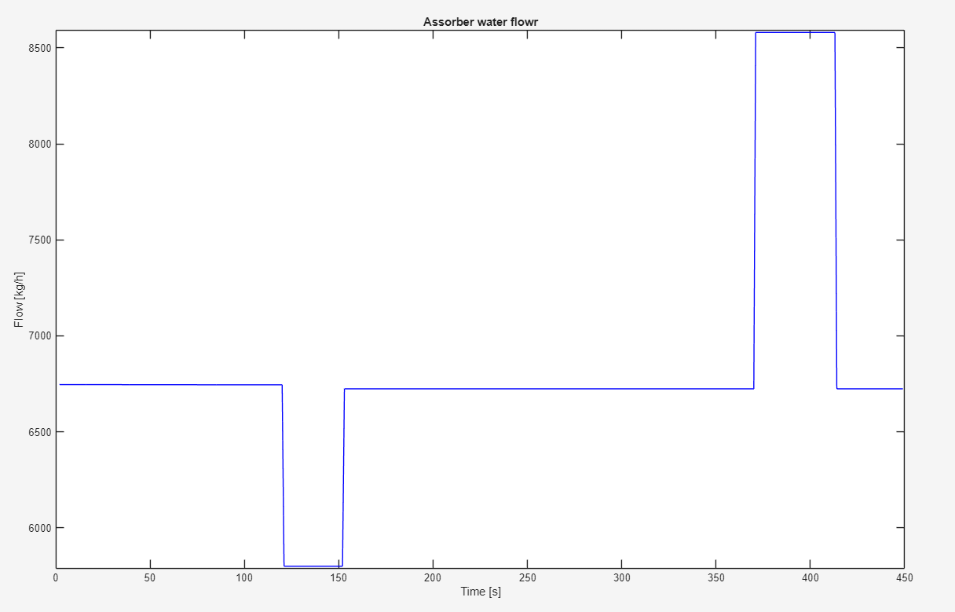
The second case study reproduces an attack on the absorption system by reducing the water flow rate (Fig. YY) supplied to the absorption column. In this case, the operator must identify the cyber attack and restore the correct water flow rate. As in the previous scenario, after a certain amount of time a second intrusion is simulated; this time the water flow rate is increased, and once again the operator is required to manually restore the correct operating value.
Cyber attack
Operator
Figure 6: Water flow in the second case studio
During the test, the operator is initially asked to operate only on the first scenario. This is followed by a debriefing session in which the case study and the cyber attack are explained in detail. Subsequently, the operator is asked to manage a couple of additional case studies simulating system faults. Only after this phase is the second cyber attack scenario ispresented, in order to evaluate whether the operator’s performance in detecting and handling cyber attacks has improved.
The two case studies follow a similar approach, although located in two different parts of the plant with different effects on the production cycle. The aim is to assess whether operators are able to improve their performance and recognize attacks after initial training. The complete test is structured as follows: presentation of the first case study with subsequent debriefing, presentation of a series of case studies regarding failures, and presentation of the second case study to see if the cyber attack detection rate increases and whether response performance improves.
  - Conclusion
In the future, the vulnerability of process plants to cyber attacks will become an increasingly significant risk; for this reason, it is necessary to adopt appropriate prevention and protection measures. One of these layers concerns the training and skills of control room operators.
To assess the level of preparedness of control room operators, a testing system and a set of case studies were developed and presented to the operators in order to evaluate their ability to detect cyber attacks and respond appropriately.
This paper presents the developed testing system, which reproduces the operation of a control station for a continuous formaldehyde production plant. In addition, two cyber-attack case studies proposed to operators during the testing phase are described.
References

Amazu C.W., Mietkiewicz J., Abbas A.N., Briwa H., Baldissone G., Demichela M., Fissore D., Madsen A.L., Leva M.C., 2024, Experiment data: Human-in-the-loop decision support in process control rooms, Data in Brief, 53, 110170.
Ani U. D., He H., Tiwari A., 2016, Review of cybersecurity issues in industrial critical infrastructure: manufacturing in perspective, Journal of Cyber Security Technology, 1, 32-74.
Bertolotti, I. C., Durante L., Hu T. Valenzano A., 2013, A Model for the Analysis of Security Policies in Industrial Networks, 1st International Symposium for ICS & SCADA Cyber Security Research 2013 (ICS-CSR 2013), 66-77.
Castro Rodriguez D. J., Pilone E., Camuncoli G., Demichela M., 2023, Implementation of a Natech Vulnerability Index in a Seveso Plant, Chemical Engineering Transactions, 100, 43-48
Chakravarthy, R., Hauser C., Bakken D. E., 2010, Long-lived authentication protocols for process control systems, International Journal of Critical Infrastructure Protection, 3(3-4), 174-181.
Coffey, K., Smith R., Maglaras L., Janicke H., 2018, Vulnerability Analysis of Network Scanning on SCADA. Systems, Security and Communication Networks, 1.
Dolgikh A., Nykodym T., Skormin V., Antonakos J., Baimukhamedov M., 2011, Colored Petri nets as the enabling technology in intrusion detection systems, 2011 - MILCOM 2011 Military Communications Conference, 1297-1301.
Genge B., Haller P., Duka A.V., 2019, Engineering security-aware control applications for data authentication in smart industrial cyber–physical systems, Future Generation Computer Systems, 91, 206-222.
Jones R. A., Horowitz B., 2012, A System-Aware Cyber Security architecture, Systems Engineering, 12(2), 225-240.
Langner R., 2011, Stuxnet: Dissecting a cyberwarfare weapon, IEEE Security and Privacy, 9(3), 49-51.
Leyden J., 2008, Polish teen derails tram after hacking train network, The Register, 11
Mayeke N. R., Arigbabu A. T., Olaniyi O. O., Okunleye O. J., Adigwe C. S., 2024 Evolving Access Control Paradigms: A Comprehensive Multi-Dimensional Analysis of Security Risks and System Assurance in Cyber Engineering, Asian Journal of Research in Computer Science, 17(5), 108-124.
Markevych M., Dawson M., 20023, A review of enhancing intrusion detection systems for cybersecurity using artificial intelligence (ai), International conference knowledge-based organization, 29(3), 30-37.
Seara J.P., Serrão C., 2024 Automation of System Security Vulnerabilities Detection Using Open-Source Software, Electronics, 13(5), 873.
Wadho, S. A., Meghji, A. F., Yichiet, A., Kumar, R., Shaikh, F. B. (2023). Encryption Techniques and Algorithms to Combat Cybersecurity Attacks: A Review, VAWKUM Transactions on Computer Sciences, 11(1), 295-305.
Xianghui C., Peng C., Jiming C., Youxian S., 2013, An online optimization approach for control and communication codesign in networked cyber-physical systems, IEEE Transactions on Industrial Informatics, 9(1), 439-450.
Yalcinkaya E., Maffei A., Onori M., 2017, Application of Attribute Based Access Control Model for Industrial Control Systems, International Journal of Computer Network and Information Security, 9(2), 12-21.
Xu T., Yang Y., Li T., Ju J., Wang Q., 2017, Review on cyber vulnerabilities of communication protocols in industrial control systems, 2017 IEEE Conference on Energy Internet and Energy System Integration (EI2), 1-6.
Zhang F., Yang J., Li J., Zhang F., Li J., Chen L., Xu D. Wamg Q., Dou Z., 2024 Integrated physical safety–cyber security risk assessment based on layers of protection analysis, Chemical Engineering Research and Design. 212, 405-420.

